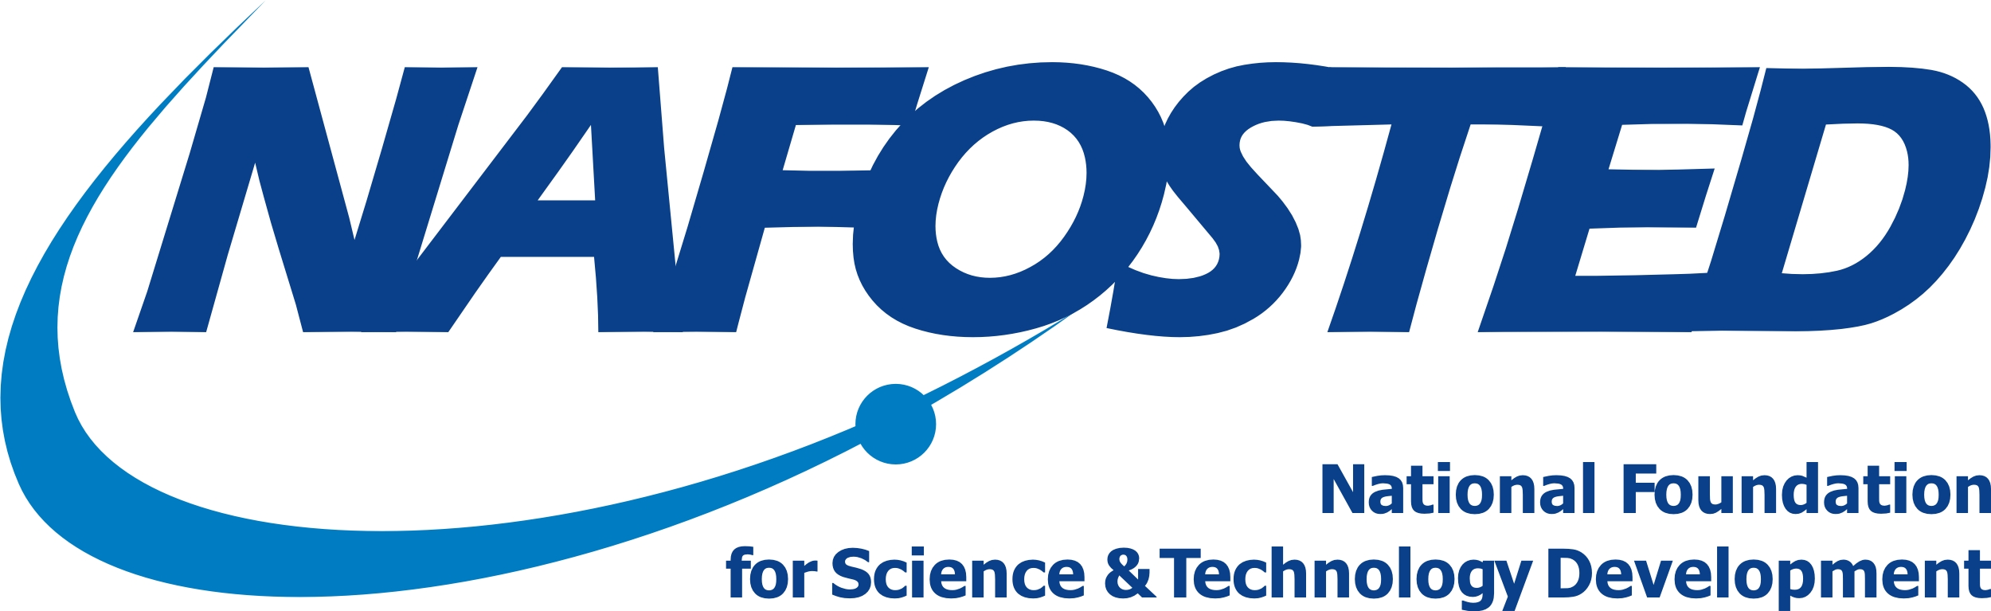
SOCIALIST REPUBLIC OF VIETNAM
Independence – Freedom – Happiness
EXPRESSION OF INTEREST FOR
UK – VIETNAM NETWORKING WORKSHOP 2017
To: National Foundation for Science and Technology Development
Full name: ……………………………………………………………………………
Research institution: ………………………………………………………………...
Telephone/Mobile: ………………………………………………………………..…
Email: …………………………………………………………………………………
Research expertise:
Natural sciences, specifically: ……………………………………………………..
Social sciences, specifically: ………………………………………………………

Short biography and description of the applicant’s research actitivies (to be printed on workshop proceedings):
…………………………………………………………………………………………………………………………………………………………………………………………………………………………………………………………………………………………………………………………………………………………………………
Detailed description of the applicant’s research orientations and research activities in the last 05 years (especially ones relevant to the workshop)
…………………………………………………………………………………………………………………………………………………………………………………………………………………………………………………………………………………………………………………………………………………………………………
Necessity, importance of workshop participation for the applicant and research institution:
…………………………………………………………………………………………………………………………………………………………………………………………………………………………………………………………………………………………………………………………………………………………………………
Research interest of the applicant’s research institution for collaboration with UK institution in the area of the workshop:
…………………………………………………………………………………………………………………………………………………………………………………………………………………………………………………………………………………………………………………………………………………………………………
Short note highlighting your expected achievement when attending the workshop:
…………………………………………………………………………………………………………………………………………………………………………………………………………………………………………………………………………………………………………………………………………………………………………
I would like to express my interest for attending the UK – Vietnam Networking Workshop organized in the framework of collaboration between National Fountion for Science and Technology Development (NAFOSTED) and Research Council UK (RCUK).
I hereby confirm to have been approved by my research institution for attending the workshop in Jakarta, Indonesia from 10-11 October 2017 if selected, and will accomplish all required duty in the workshop, be responsible for payment of additional costs if any (besides the provided funding) for my participation, as well as conform to current laws and regulations of hosting country, of Vietnam and of NAFOSTED.
Research Institution Approval Applicant

Date: |  | Date:

